# 3.7 Event Management Timeline

|  |  |  |
| --- | --- | --- |
| JANUARY | Start of marketing presentation (design of poster, flyer, website, backdrop, ballons, booklet & video teaser) | |
| Social Media (consistent updates)Release of first teaser1st Marketing Wave: distribute 100 Posters | | FEBRUARY |
| MARCH | Social Media (consistent updates)2nd Marketing Wave: distribute detailed 100 posters & 2000 flyers | |
| Social Media (consistent updates) | | APRIL |
| MAY | Social Media (consistent updates)3rd Marketing Wave: distribute 1000 flyers (as a reminder) and 500 (?) balloons | |
| CELEBRATION OF 11st ANNIVERSARYDistribute 1500 (?) event booklets and 5000 goodie bags | | JUNE |

# 

# 4. Sponsorship

**Why Nottingham Indonesian Festival?**

Nottingham Indonesian Festival is a free admission cultural event, targeting all age groups. Running for the past 10 years with the record breaking of 3,500 people attendees in 2013 and located in the greenest campus in UK- the University Park, University of Nottingham, Nottingham Indonesian Festival is the largest Indonesian event in UK that provides the greenest environment for everyone to experience Indonesian Culture. Furthermore, being in East Midlands and the high frequency of public transportation give more than just a convenience for people all over UK to attend the event in Nottingham more easily than in any other cities. Nevertheless, University of Nottingham maintains strong relationships with Asian countries with their overseas campuses in Malaysia and Ningbo, China.

# 

# 4.1 Sponsorship Package

# We focus our pre-event and post event marketing mainly through social media such as facebook, twitter and Youtube to reach out to all people all over the world. Through social media, we believe that more people over the world will be aware of Nottingham Indonesian Festival, thus an increase in awareness and understanding of Indonesian Culture.

WEB

|  |  |  |  |  |
| --- | --- | --- | --- | --- |
|  | Primary | Gold | Silver | Bronze |
| Facebook | 3-4 times per week Mention | Weekly  Mention | Fortnightly  Mention | Monthly  Mention |
| Twitter | 3-4 times per week Mention | Weekly  Mention | Fortnightly  Mention | Monthly  Mention |
| Website | Exclusive page: Logo and Details of Company (unlimited word) | Logo and Details of Company (150 words) | Logo and Details of Company (100 words) | Logo and Details of Company (50 words) |
| Press Release | Mention | Mention | - | - |
| You Tube (video) | 2 seconds with exclusive frame | 2 seconds | 1 second | 1 second |

# Social Media

Social Media is an effective tool to expose millions of people instantly about Indonesian Festival. Our established Facebook page, Nottingham Indonesian Festival, has attracted **more than 600 likes** and reached almost 2700 friends daily. Meanwhile, an official twitter account will also be set up to provide the most updated news and information. Primary sponsorship offers an exclusive sponsorship album on the Facebook page for sponsors to put up their marketing materials and together with twitter; there will be mentions with unlimited words about the primary sponsors weekly. Primary sponsorship offers an exclusive 2 seconds frame of our promotional videos and flashbacks will be uploaded on YouTube and shared to other channels, as well as an individual one-page of the primary sponsor profile information on our official website. On the other hand, albums will also be created for other sponsorships with lower frequency of mentions.

Primary sponsors can send their marketing materials to their assigned sponsorship officer.

PRINT

|  |  |  |  |  |
| --- | --- | --- | --- | --- |
|  | Primary | Gold | Silver | Bronze |
| A3 Poster | 3”x 2”  or equal | 2”x 1.5”  or equal | 1.5”x 1”  or equal | - |
| A5 Flyer | 1.5”x 1”  or equal | 1”x 0.5”  or equal | - | - |
| Committee T-Shirt | 2”x 1.5”  or equal | 1.5”x 1”  or equal | 1”x 0.5”  or equal | - |

**A3 Poster**

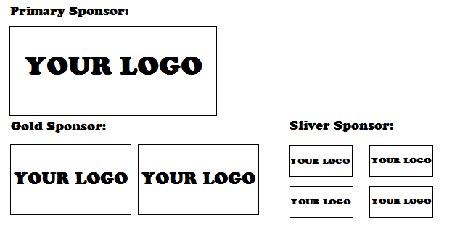

**Silver Sponsor:**

**A5 Flyer**

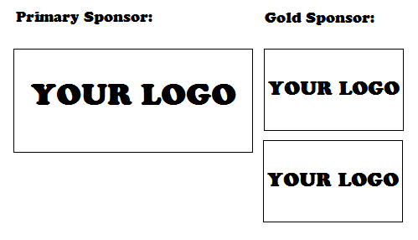**Committee T-shirt**

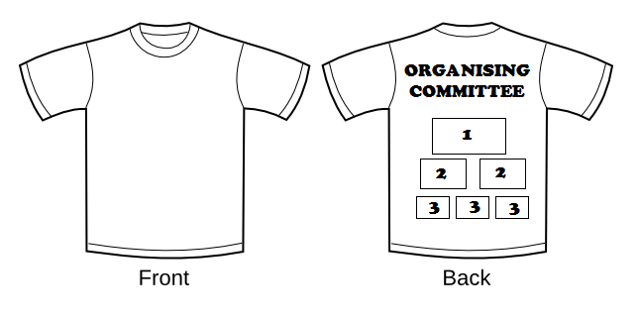

Legend: 1 – Primary Sponsor Logo

2 – Gold Sponsor Logo

3 – Sliver Sponsor Logo

The Marketing Department will release new poster design every month and distribute them to all Indonesian Oriental Mart and other potential Oriental Marts in UK. Posters will also be pasted in all campuses in Nottingham to gain awareness from students and staff in Nottingham. Several designs will be made for Flyer as well with the back page containing information of Indonesia islands. Flyers will be distributed mainly in Nottingham, targeting the locals during the last 2 months before the event. Nottingham Indonesian Festival 2013 Organising Committee will be wearing the customised committee T-shirt during the event day with the Indofest Logo at the front and the words “ORGANISING COMMITTEE” at the back of the shirt.

ON-SITE

|  |  |  |  |  |
| --- | --- | --- | --- | --- |
|  | Primary | Gold | Silver | Bronze |
| Exclusive Booth | 1 | £100 | £200 | £300 |
| Banner | 25”x15”  or equal | 15”x10”  or equal | 10”x7”  or equal | 7”x5”  or equal |
| Exclusive Sessions | 30 minutes | - | - | - |
| Mention on Stage | YES | YES | YES | YES |
| Title  *(E.g. Nottingham Adventure Games by <company name>)* | The **WHOLE** event | ONE Sport section **AND** ONE Art Section | ONE Sport section **OR** ONE Art Section | ONE Art Section |

**Banner**

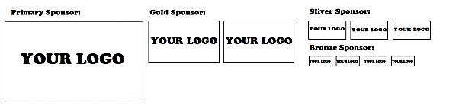

Banners will be put up as the stage backdrop and outside the West Entrance Field during the event day. Primary Sponsorship offers an exclusive booth and 30 minutes session on stage to promote their companies and to have their logo printed on our promotional items for giveaways

Talk more about the stage title.

ADD-ON

|  |  |  |  |  |
| --- | --- | --- | --- | --- |
|  | Primary | Gold | Silver | Bronze |
| Balloons | £200 | £250 | £300 | £350 |
| Backdrop | £500 | £600 | £700 | £800 |
| IndoFest Event Booklet | £350 | £400 | £450 | £500 |
| Goodie Bag | £900 | £950 | £1000 | £1100 |
| Kids’ Corner | £100 | £150 | £200 | £250 |

**Explanation:**  
  
Balloons (pre-event marketing strategy)

The balloons will be printed with 2 sides – one side with Nottingham IndoFest logo and another side will be a sponsor’s logo. Approximately there will be 500 balloons distributed – 300 balloons will be distributed only in the 3rd marketing wave (mainly in cities and parks) while the rest will be placed at booths on the celebration day. The distribution of balloon is effective because there will be kids coming to Indofest and also, at the same time it could be used as a reminder to the society.

Backdrop (on site marketing strategy)

The backdrop with the dimensions of 3m x 2m will be placed at the photobooth. The photobooth will be a programme free of charge for people to take photos with a cutout famous Indonesia landmarks on their hands and the backdrop behind them. Hence, the logos on the backdrop are clearly seen in every photo taken. Furthermore, interviews will also be conducted in front of the backdrop. The logo for primary sponsor will be put the same size as the indofest logo while gold sponsor will their logos smaller. A 2-D illustration of the backdrop is shown below.

IndoFest Event Booklet

The Indofest event booklet consists of 12 A5-papers, which includes Indofest map, schedule and most importantly advertisements. These event booklets will be placed on the information booth and will be distributed to groups on the celebration day since the visitors mostly arrive in groups. Since there will also be an e-book available and our makerting target for this year Indofest is to reach 4000 people, hence 1500 copies of event booklet will be printed.

Goodie Bag (Pre-event and on site marketing)

Before the event, an announcement will be made to explain that there will be a free goodie bag to be given away on the celebration day. All they need to do is just filling up a form, which asks about their occupation, age group, gender, nationality and which UK’s city they are staying. Then they will be given a unique code that can be used to redeem it on the same day. Logo on the bag and their POS materials can be put inside the bag. This would be a good strategy because from this, statistics of attendees can be obtained and sponsors would be able to know who has been exposed to their products and services.

Kids Corner (on site marketing strategy)

A booth specially decorated with balloons to accommodate children to know more about Indonesia Landmarks by coloring the landmarks. Sponsor logo will be printed on the balloons and the drawing papers.

How many children do we expect?

Why is this effective? Exposure wise?